CENTRAL BAPTIST CHURCH NEWSLETTER
JULY 2026

“No matter who you are or where you’ve been, you are welcome here!

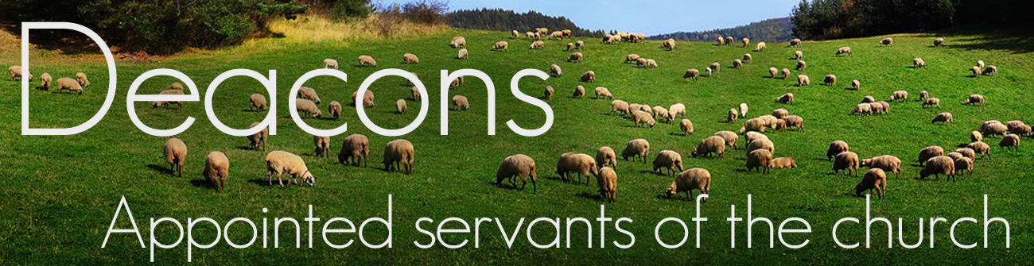

THE FRUITS OF THE HOLY SPIRIT

“But the fruit of the Spirit (the result of His presence within us) is LOVE (unselfish concern for others), JOY,

(inner) PEACE, PATIENCE (not the ability to wait, but how we act while waiting), KINDNESS,

GOODNESS, FAITHFULNESS, GENTLENESS, SELF-CONTROL. Against such things there is no law.”

Galatians 5:22-23 (Amplified Bible)

THOUGHT FOR THE DAY: You can not receive these fruits through sheer willpower. When a believer
chooses to yield to the Holy Spirit in their daily lives, then your old sinful
desires can be pushed out. Now there’s room for the fruits of the Holy Spirit
to grow in you. When you choose to live a Spirit-led life, you make God
smile. Amen!

Submitted by Candee Varney






July 18th is the date for our next Community Breakfast
7:30 a.m. Prep
9:00 a.m. Serve
All are welcome

Looking for volunteers to serve breakfast and help with clean up.

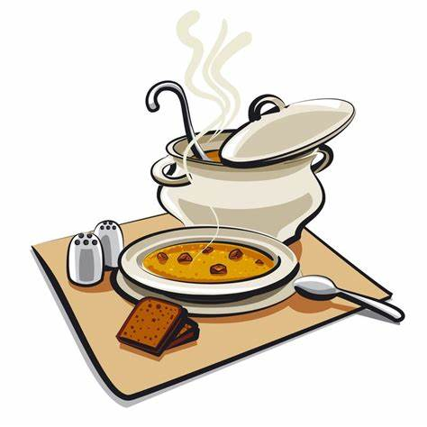

The next Soup Kitchen is Wednesday, July 30th at 2:00 p.m.

On the menu
Grilled hot dogs, salad & dessert

Looking for volunteers to help with cooking, serving and cleanup.

Please note anyone who handles food is required to wear a hairnet or baseball hat and gloves. Hairnets and gloves will be provided.



JULY
1 Frank Tompkins
2 Sabrina LaBombard
8 Christina Falardeau, Diane Spitzer
9 Teresa Rowe
11 Candee Varney
15 Dalen Mochak, Phoenix Iserman
17 Christine Tompkins
18 Ian Burgess
20 Raina Ellinger
23 Lainna Dexheimer
24 Gary Ellinger, Aimee Tompkins
25 Ken Frisbie
27 Maricel Ellinger
28 Pastor Jerrie Matney
30 Liam Hamilton
31 Khole Dexheimer, Eliza Whelan, Bob Eck

ANNIVERSARIES
9 Frank & Helena Mochak
10 Jake & Alice Robinson

Congratulations
to our graduates
Dipo Soyele
Westfield High School
Lily Vaddy
Westfield High School

and our scholarship recipients
Dunni Soyele,Dipo Soyele &
Lily Vaddy



Join us on July 14th for Second Sunday Fellowship, held from 6:00–7:30 P.M. in the adult classroom. This gathering isn’t a Bible study — it’s a guided conversation reflecting on that morning’s sermon. It’s a special opportunity to connect with one another, and find encouragement and community as we engage together with God’s word.




Church Council will not meet in July. Regular monthly meetings will resume on Monday, August 10th at 6:00 P.M.

Also, Youth Group is taking the month of July off and will meet again in August.

It was a pleasure for me to come to service at Central Baptist Church again. It was so nice to be able to see some of my friends. I want to thank you so much for the lovely dinner you prepared. Thank you all so much. The Lord bless you all.
Love
Mabel Brucknak

