CENTRAL BAPTIST CHURCH NEWSLETTER
JUNE 2026
“No matter who you are or where you’ve been, you are welcome here!

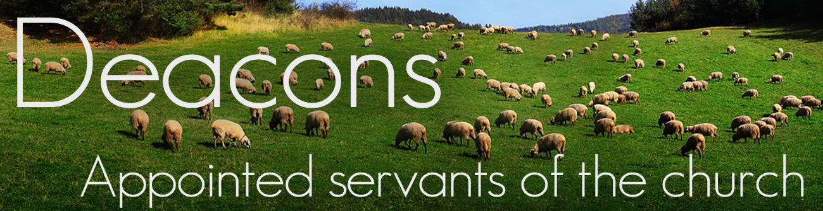

“AMEN”, THE FINAL WORD

According to the Webster’s dictionary, the word, “Amen”, is a solemn expression of agreement; be it so, as after a prayer.

In the Bible, “Amen” is a Hebrew word meaning “truly”, “it is true”, or “so be it”, acting as a solemn affirmation of truth, agreement, or faith. It confirms that what was said is trustworthy, binding, or a sincere request for God to fulfill a prayer.

Jesus is called the “The Amen”, highlighting Him as the faithful and true witness. It establishes Jesus’ ultimate authority and role as the source of creation. (See Revelation 3:14)

“For every one of God’s promises is “Yes” in Him (Jesus). Therefore, through Him we also say “Amen” to the glory of God.” (2 Corinthians 1:20 CSB)

THOUGHT FOR THE DAY: Have you ever paid attention to Revelation 22:21? “The grace of the Lord Jesus be with everyone. Amen.” The final word in the Bible is “Amen”. So if you are one of God’s people and you love the Lord, say “Amen!”

Submitted by Candee Varney


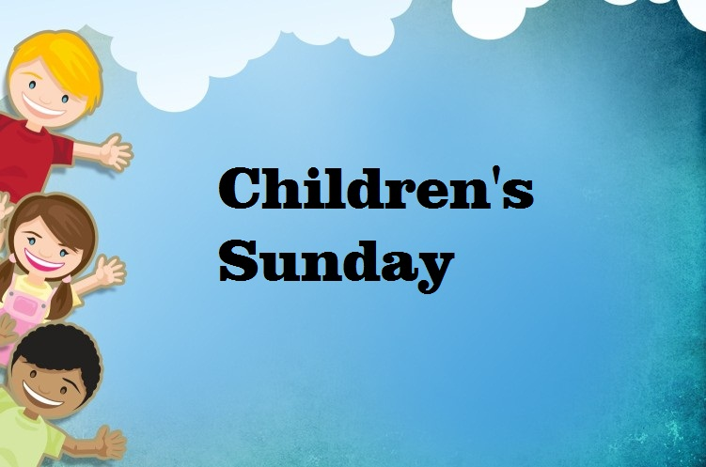

June 21st is Children’s Sunday

Let’s celebrate the end of another school year. In church we will recognize graduates and scholarship recipients.



JUNE 20th is the date
for our next free
community breakfast.

Prep is at 7:30
Serving at 9:00

COME JOIN US!


Dear Church Family,

Thank you all so much for lifting us up in prayer during Merian's long illness and hospitalizations. Receiving your cards, messages, and meals really helped and brought us comfort. Merian is still recovering. We hope to see you at church sometime soon, as she looks forward to playing the piano and organ for worship again.

With love and appreciation,

George and Merian Rogers



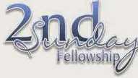

Beginning on June 14th, we will be hosting Second Sunday Fellowship from 6:00-7:30 P.M.

This will a special time to come together for connection, encouragement and community. We invite everyone to join us each month for this meaningful time of fellowship.

We look forward to seeing you there!
Youth Group Meeting
Sunday, June 14th
2-4 P.M.
Hays Hall
If anyone needs a ride, please let Chrissy Falardeau know
413-335-0084

2 Jaiden Ellinger, Heather Dexheimer
4 Bill Kedzierski
8 Vincent Placzek
16 Emily Ingraham
18 Hannah Placzek
20 Nathan Lent
22 Brian Rucki, Doyin Soyele
23 Sue Ellinger, Courtney Tesini
25 Robert Czarnecki
26 Norah Burgess, Dave Ritchie
27 Lilly Thieme
28 Jeannette Balboni, Amanda Wetherell

And Anniversaries!
11 Adrian & Kathy Larue
18 Tim & Joyce Bates
29 Matt & Jean Goodreau



Upcoming Dates

July 29th
&
September 30th
2 p.m.
Looking for volunteers
Help us cook and serve a meal



We want to express our deepest gratitude to an incredibly generous anonymous donor. Their recent contribution entirely funded our purchase of brand-new pew bibles for our sanctuary. These scriptures will be a guiding light and a source of great comfort for our congregation for years to come.
Thank you!!

Council Summer Break

Please note that the Church Council will not meet during June or July. Regular monthly meetings will resume on Monday, August 10th at 6:00 PM.



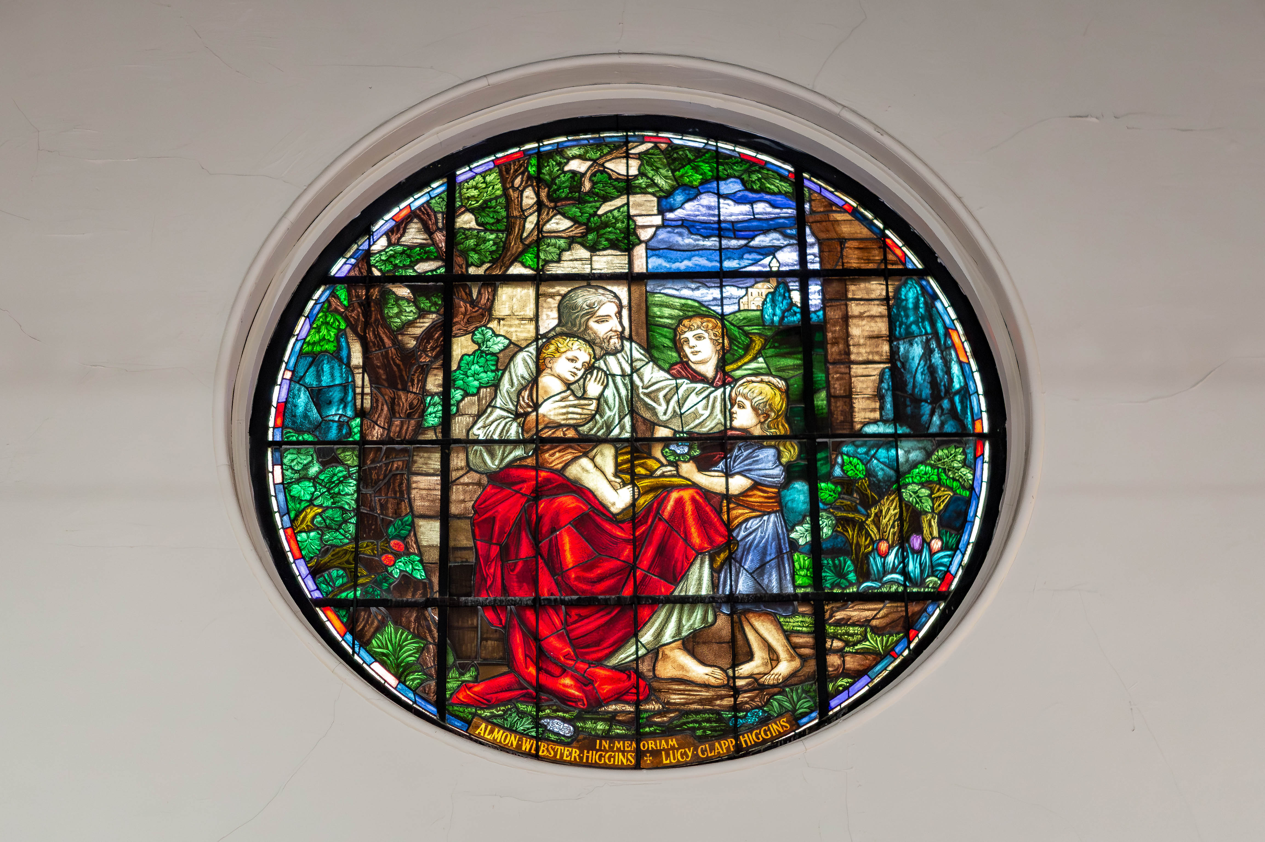
Stained Glass Presentation & Potluck

Join us on Sunday, June 28, immediately following our worship gathering, for a special presentation by Stained Glass Resources, Inc. They will share details regarding their quote and plan for repairing our beautiful stained-glass windows and answer any questions. Following this brief informational meeting, we will gather in Hays Hall for a potluck lunch. Come learn about the preservation of our church home and enjoy great food and fellowship with your church family!


For the month of June, we will be collecting for One Great Hour of Sharing (OGHS). This offering helps provide:
- Emergency relief 24/7 for urgent or acute needs brought about by disasters of natural or human origin;
- Development projects focused on meeting chronic human need by enabling individuals or groups to establish or maintain a more adequate quality of life;
- Ministries to displaced persons focused on holistic ministry to immigrants, refugees, asylum seekers, and migrants-those within the U.S. and around the world who find themselves someplace other than what they have known to be home.

