CENTRAL BAPTIST CHURCH

**MARCH 2025**

“No matter who you are or where you’ve been, you are welcome here!

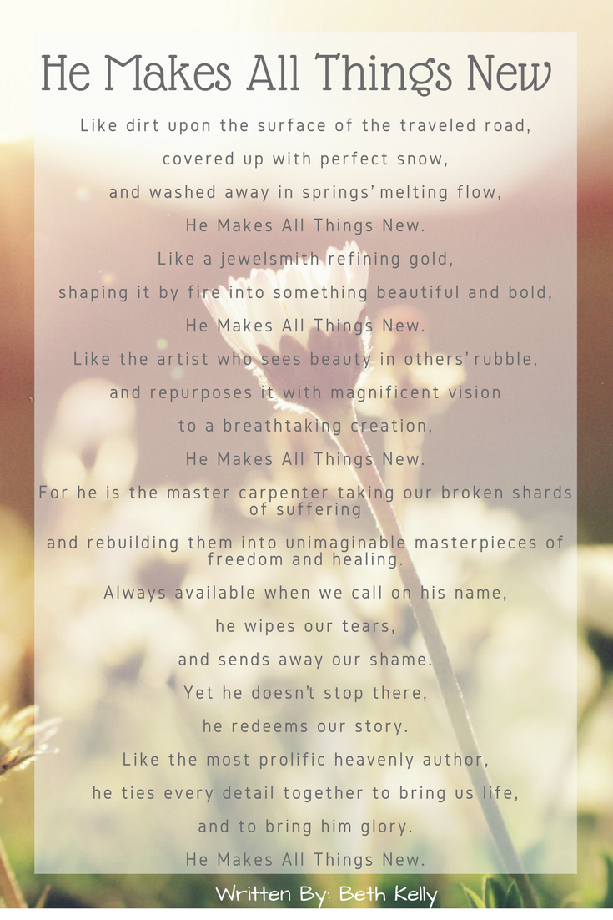

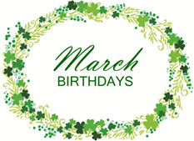



March 2nd – Rev. Patrick McMahon

March 9th – Rev. Tom Rice

March 16th – Rev. Luke Callender

March 23rd – Rev. Patrick McMahon

March 30th - TBD

3 Jennifer Falardeau

4 Diane Ziemba

7 David Iserman

11 Bill Stewart

13 Pastor Painchaud, Loretta Tobias

14 Jeremy & Justin Shay

16 Josh Ellinger,

17 Megan Ellinger

19 Audrey Ritchie

20 Matthew Thieme

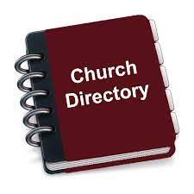

Our church directory has been updated. Copies are available on the table in the Narthex. If you would like a copy sent electronically, please let Gail know.

23 Sherri Gelina

25 Emily Czarnecki, Dave Burgess

26 Ruth Bloking

27 Jake MacAdam, Leah Rucki

30 Gina Holzapfel, Cameron Gaj,

Caroline Laframboise

31 Heather Stewart, Hilary Placzek

***AND ANNIVERSARIES……***

16 Loretta & David Tobias



**Sunday, March 9th**

**Daylight Saving Time Begins**

**Remember to set your clocks one hour ahead**

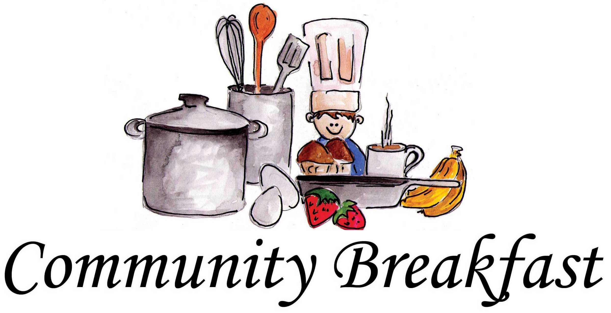

Saturday, March 15th

Prep 7:30 A.M.

Serve 9:00 P.M.

All are welcome!

.

****.

TABCOM MISSIONWORKS 2025

SAVE THE DATE

October 25, 2025



For the month of March, we will be collecting for America for Christ. The AFC offering is a vital resource that empowers ABHMS to support life-changing ministry programs provided by diverse American Baptists in local communities. Your contributions deliver essential support to diverse community ministries, offer resources and grants to ministry leaders in multicultural settings, and promote Christian education and continuous learning experiences for church leaders across the U.S. and Puerto Rico. Missions has set a $500 goal. Please donate to this worthy cause.



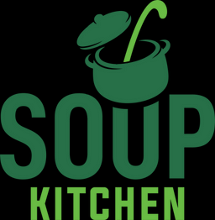

Mark your calendars!

The next Soup Kitchen is

Wednesday, April 30th beginning at 2 p.m.

They are always looking for help with cooking, packing, serving and clean up.



TABCOM ANNUAL GATHERING 2025

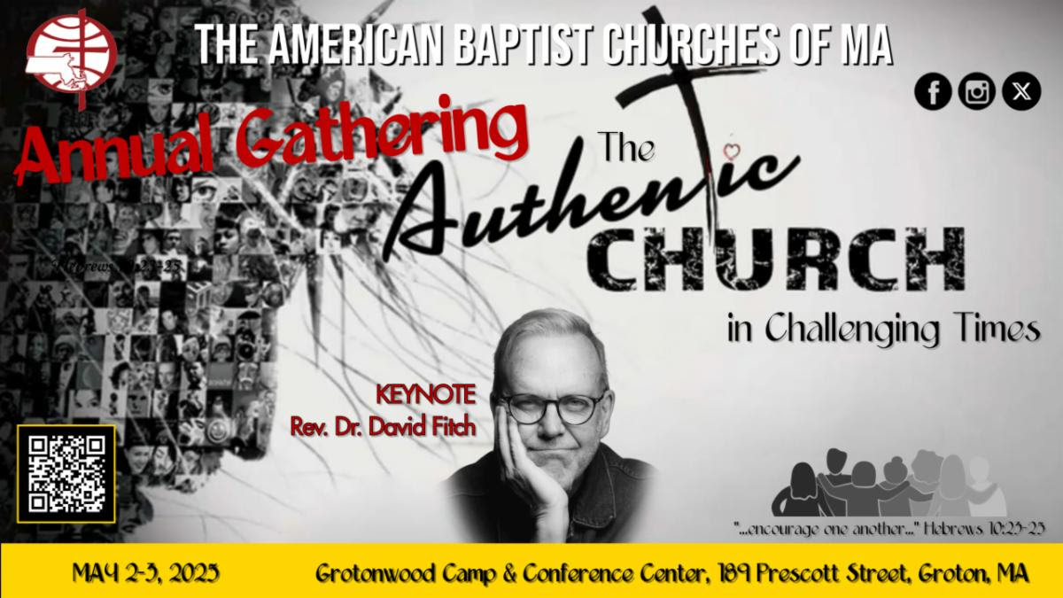

Given the current climate of uncertainty and the challenges we all face, now more than ever, we are called to stand together in faith, unity, and encouragement. As the body of Christ, we are not alone—we are strengthened by one another and by the unwavering faithfulness of our God.

We invite you to join us for our upcoming Annual Gathering (#TAG2025), themed "The Authentic Church in Challenging Times," inspired by the powerful words of Hebrews 10:23-25.

This verse is a profound reminder that our God is faithful, and He calls us to remain steadfast in hope, to uplift one another, and to be a light in the midst of uncertainty. As we gather, we will explore what it means to be an authentic church—a people of bold faith, resilient love, and unwavering commitment to the Gospel, even in the face of difficulty.

Come and be renewed. Come and be encouraged. Come and be reminded that we are stronger together.

We can’t wait to see you at #TAG2025!

Our Keynote speaker is Rev. Dr. David Fitch. You can read more about David on our TAG2025 website.

Registration will be open soon.

May 2-3, 2025

Grotonwood Camps and Conference Center

189 Prescott Street, Groton, MA