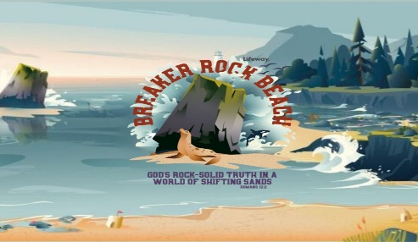[](https://www.google.com/url?sa=i&rct=j&q=&esrc=s&source=images&cd=&cad=rja&uact=8&ved=2ahUKEwjz3ai3wL_bAhWSLHwKHdcxAxEQjRx6BAgBEAU&url=http://topbookings.co/vacation-bible-school-flyer-templates/vacation-bible-school-flyer-templates-new-vacation-bible-school-flyer-templates-fresh-vbs-clipart-collection/&psig=AOvVaw3gB4-Pz528SfEEr1YGLfnF&ust=1528390478953488)

**Central Baptist Church**

115 Elm St.

Westfield, MA

413-568-0429

VBS Registration

Aug 12, 13, 15, & 16th

(no Wednesday)

5-8 P.M.

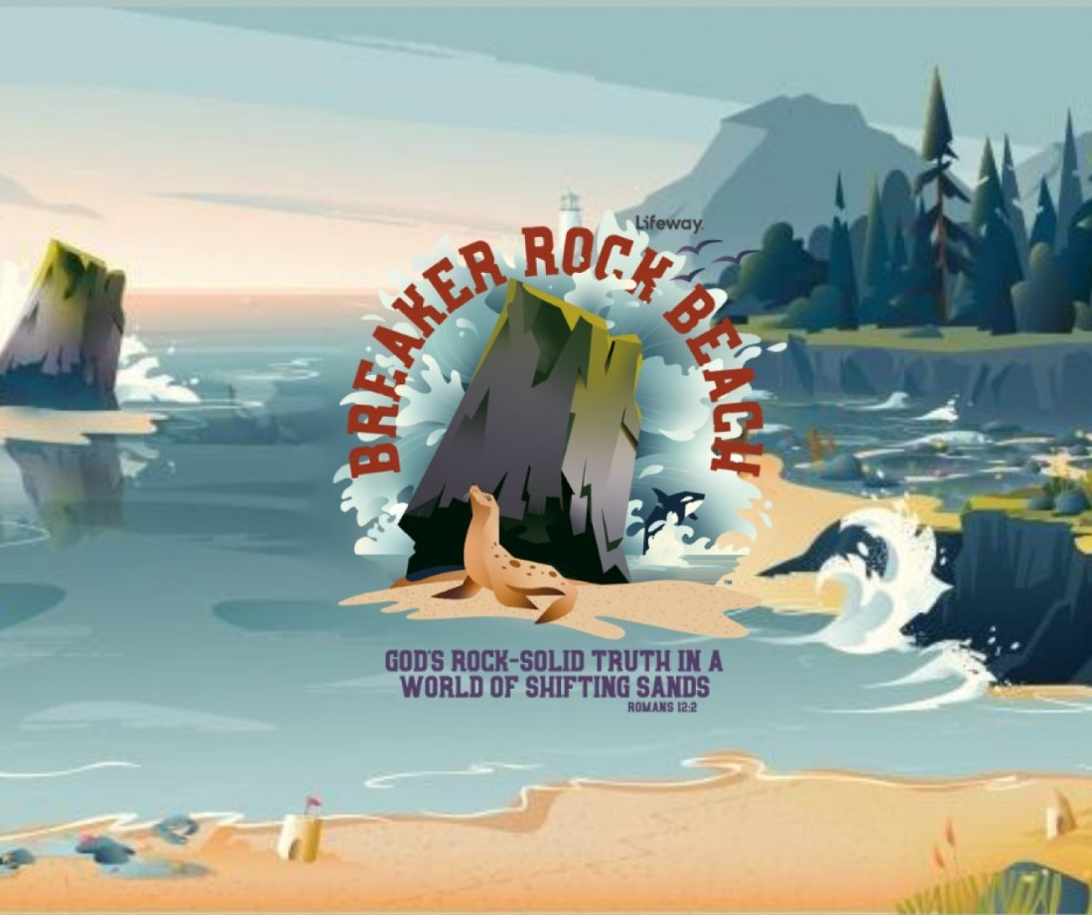

Student's Name___________________________________________________________________________________

Street Address____________________________________________________________________________________

City_______________________________________________State____________________Zip Code_______________

Home Telephone___________________________________________________________________________________

Parent's Cell______________________________________________________Do you accept Text messages? Y N

Email Address____________________________________________________________________________________

Child's age_________________Birth Date________________Last Grade Completed____________________________

Emergency Contact Person_______________________________Emergency Phone #___________________________

Mother's Name__________________________________Father's Name______________________________________

Other and Relationship to Student_____________________________________________________________________

Allergies and/or Medical Conditions __________________________________________________________________

________________________________________________________________________________________________

Home Church______________________________________________________________________________________

Siblings and Ages___________________________________________________________________________________

I give my consent that my child may appear in any photography, audio tapes, or videos while participating in the VBS experience at Central Baptist Church. I understand that these pictures, tapes, and/or videos are the property of Central Baptist Church.

**Guardian Signature_________________________________________________Date____________________________**

*How did you hear about Vacation Bible School?* __________________________________________________________

**CENTRAL BAPTIST CHURCH**

**www.centralbaptistchurchwestfield.com**